UNDER EMBARGO UNTIL 29 AUGUST 2024, 8 AM CET

Geneva Watch Days 2024:
HYT Launches the First-Ever ‘Millésime Edition’
for the Fall-Winter 2024-2025 Season.

Celebrating the ‘T1 Series’ collection and its spirit
of uncompromising innovation, HYT presents three new models
in a limited edition defined by availability, not quantity
– from September 2024 to April 2025 only.

Purple, Green, and Chocolate: Three all-new colors – refined, warm, and autumnal-wintery – for three new versions of the already iconic ‘T1 Series’, HYT’s latest contemporary creation.

Available exclusively this Fall and Winter, from September 2024 to April 2025.

HYT unveils an exclusive collection featuring three new colors – purple, green, and chocolate – that will elegantly enhance the dials of the famous ‘T1 Series’ this fall-winter season.

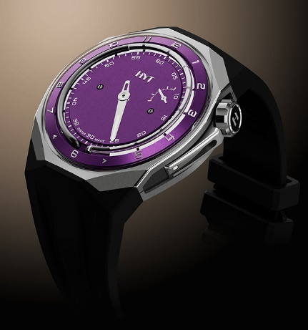 | 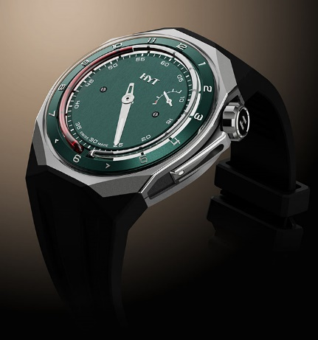 | 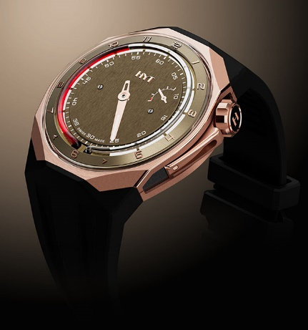

Sophisticated and refined, these three new colors – each one a first for HYT – embody the excellence of haute horlogerie, while perfectly aligning with the zeitgeist. They will be available as limited editions in time (not quantity), only between September 2024 and Watches and Wonders 2025.

With a more compact diameter of 45mm, and a slimmer design that enhances wrist ergonomics, the new T1 Series combines a refined, distinctive, and contemporary style with undeniable presence and astonishing comfort. In colorways both bold and trendy, the watches honor the brand’s core pillars: science, technology, haute horlogerie, and design – with perfect mastery of its hallmark fluidic time display mechanism. For this special edition, a vibrant red fluid in the chocolate and green models, and black in the purple version, adds a distinctly daring touch to the dial.

A TRIO OF DIVINE HUES.

2024 is a special year for HYT, a year of renewal with the notable launch of the new ‘T1 Series’ in the spring. This collection celebrates contemporary elegance on the wrist with a reduced diameter and a slimmer design.

To mark this new chapter, HYT presents three new T1 models, elegantly dressed in purple, green, and chocolate, whose dials feature a vertical grain satin finish that captures the play of natural light like no other.

In French, ‘millésime’ refers to a year in which a particular wine was produced. Here we have an exceptional vintage that will be available only from autumn until mid-spring – from September 2024 to April 2025 – without a limit in terms of quantity. The T1 Series, distilled from the essence of HYT, impresses with an innovative, more ergonomic diameter of 45mm, reflecting a new stylistic signature for the brand that emphasizes refined, balanced, and perfectly legible dials.

In tune with the times, the T1 Series collection was conceived from the outset to meet new expectations. A reduced case size (45mm), a more ergonomic silhouette, a subtly faceted octagonal shape, a fully closed dial designed to achieve absolute harmony – the T1 Series exudes meticulous attention to detail with an ultra-contemporary vibe. Tackling complex technical and aesthetic challenges, and challenging conventions, this new collection opens a more refined space for expression.
This triptych of watches stands out for the beauty of their dial, each with a vertical grain satin finish, traversing the minutes and enhancing the chapter ring with a contemporary palette – green, purple, or chocolate – that adds a distinctive elegance. Two case variations further enhance the special nature of these pieces: one in titanium and DLC titanium; the other, more overtly precious, in 5N gold complemented by DLC titanium. The green and purple dial versions offer a unique contrast with the titanium and DLC titanium case, while the 5N gold and DLC titanium case elegantly accentuates the softer tones of the chocolate dial.
A HYT hallmark, mechanical components and technological advancements merge in perfect harmony. The domed crystal, elegantly evoking a bell, made of anti-reflective sapphire, seems to float above the dial; the open sapphire case back reveals HYT’s unique mechanism. Powered by the two iconic bellows, the movement of fluids is orchestrated by a hand-wound 501-CM caliber, itself composed of 352 parts. Another example of thoughtful ergonomics: the screw-down crown positioned at 2 o’clock, made from satin-finished and micro-blasted titanium and DLC titanium (or 5N gold and DLC titanium), ensures the case remains water-resistant up to 50 meters, combining functionality and aesthetics with flawless precision.
The fluidic time display mechanism places the hour indicator below the glass tube filled with liquids, with a 6 to 6-hour scale. Also a first: the fluid is colored red on the chocolate and green versions, and black on the purple dial version. It moves smoothly and continuously, allowing hours to be read by observing the position of the colored fluid between the chapter ring graduations. Every 12 hours, the fluid returns to its initial position in a retrograde motion.
Minutes are precisely displayed on a dedicated sector around the central dial with Arabic numerals. The exclusive HYT manufacture caliber beats at 28,800 vibrations per hour, ensuring a 72-hour power reserve indicated by the sectoral subdial positioned at 2 o'clock.
Provided each watch comes with a strap that matches the dial and a black strap. Featuring a straight taper elegantly integrated into the watch’s architecture, it follows the natural curve of the wrist, ensuring unparalleled comfort and remarkable ease of wear. A new interchangeability system, incorporated into the watch case and specially designed for this collection, required a year of research and development before it was approved. A push button on the back of the watch allows the strap to be removed with a click. A titanium (or PVD titanium for the 5N gold/titanium model) pin buckle comfortably secures the watch on the wrist.

The foundations of HYT’s fluidic time display mechanism
HYT watches are a unique blend of science, technology (developed by PRECIFLEX SA), haute horlogerie, and design. Inspired by the workings of clepsydras that kept time for the pharaohs, HYT timepieces build on two reservoirs made of extremely flexible alloy bellows, located at 6 o'clock and connected to each end of a glass capillary tube. One reservoir contains a colored liquid, while the other holds a transparent one. Driven by the watch movement, the first reservoir compresses while the other expands, causing the liquids to move within the capillary. The two liquids are immiscible (do not mix), with the molecular repulsion force keeping them separate, creating a visible demarcation between the two: the meniscus.
As the hours pass, the liquid moves, and with it the demarcation line that graphically indicates the time along the dial's periphery. Throughout the day, the tube fills over twelve hours with the colored liquid, and when it reaches the end of the capillary, it returns to its initial position in a retrograde motion, beginning a new twelve-hour cycle.
Protected by seven patents, this invention was honored with the Innovation Prize at the Grand Prix d’Horlogerie de Genève in 2012. It is a technical innovation that presides over all aspects of the HYT design and its three-dimensional architecture.


spécifications techniques

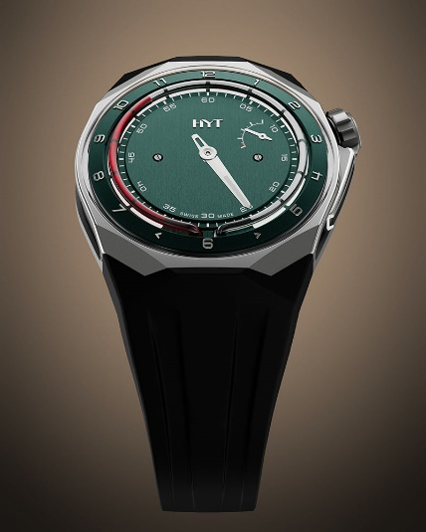 | Model  T1 Titanium Green  Millésime Edition  Reference: H03343-A  Suggested price: CHF 50’000 (excl. taxes)  Caseback ENGRAVING: T1 46  Non-contractual image
Case  - Titanium and black coated satin finished titanium  - Titanium crown  - Sapphire crystal with anti-reflective coating  Dial  - Green coated brass  - Rhodium plated appliques, white decals,  SLN White C1 / WL  - Red liquid inside borosilicate capillary tube  - Water-resistant 50 m  Movement  - Ref.: 501-CM (352 pieces)  - Type: Mechanical  - Frequency: 28,800 vib/h (4 Hz)  - Jewels: 41  - Winding: Manual  - Power reserve: 72 h  - Finishing: Finely sand-blasted and satin-finished  - Coating: Black and silver coating |  | Functions  - Fluidic retrograde hours  - Central minutes hand  - Power reserve hand  hands  - Rhodium plated polished minutes hand, white SLN  - Rhodium plated polished power reserve hand,  white SLN  straps  - Black rubber strap  - Green rubber strap  clasp  - Pin buckle in titanium  - Satin & sand-blasted finishes  Dimensions  - Width: 45,30 mm  - Length: 46,30 mm  - Thickness: 17,20 mm

spécifications techniques

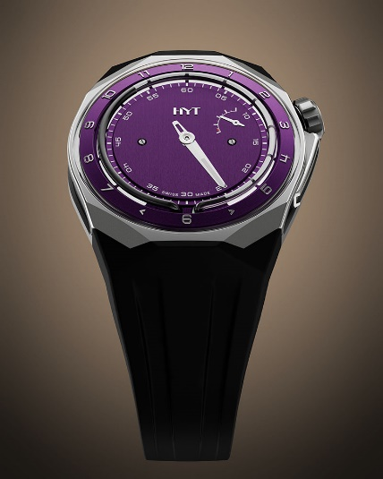 | Model  T1 Titanium Purple  Millésime Edition  Reference: H03344-A  Suggested price: CHF 50’000 (excl. taxes)  Caseback ENGRAVING: T1 47  Non-contractual image
Case  - Titanium and black coated satin finished titanium  - Titanium crown  - Sapphire crystal with anti-reflective coating  Dial  - Purple coated brass  - Rhodium plated appliques, white decals,  SLN White C1 / WL  - Black liquid inside borosilicate capillary tube  - Water-resistant 50 m  Movement  - Ref.: 501-CM (352 pieces)  - Type: Mechanical  - Frequency: 28,800 vib/h (4 Hz)  - Jewels: 41  - Winding: Manual  - Power reserve: 72 h  - Finishing: Finely sand-blasted and satin-finished  - Coating: Black and silver coating |  | Functions  - Fluidic retrograde hours  - Central minutes hand  - Power reserve hand  hands  - Rhodium plated polished minutes hand, white SLN  - Rhodium plated polished power reserve hand,  white SLN  straps  - Black rubber strap  - Purple rubber strap  clasp  - Pin buckle in titanium  - Satin & sand-blasted finishes  Dimensions  - Width: 45,30 mm  - Length: 46,30 mm  - Thickness: 17,20 mm
spécifications techniques

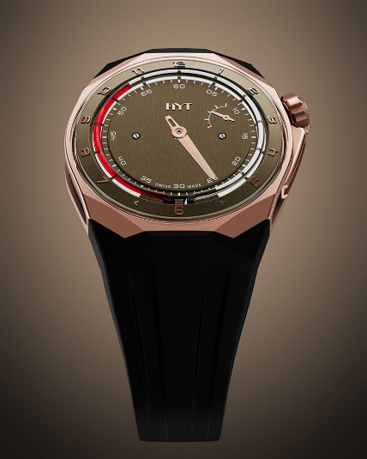 | Model  T1 5N Gold Titanium Chocolate  Millésime Edition  Reference: H03345-A  Suggested price: CHF 66’000 (excl. taxes)  Caseback ENGRAVING: T1 48  Non-contractual image
Case  - 5N gold and black coated satin finished titanium  - 5N gold crown  - Sapphire crystal with anti-reflective coating  Dial  - Chocolate coated brass  - 5N gold plated appliques, white decals,  SLN White C1 / WL  - Red liquid inside borosilicate capillary tube  - Water-resistant 50 m  Movement  - Ref.: 501-CM (352 pieces)  - Type: Mechanical  - Frequency: 28,800 vib/h (4 Hz)  - Jewels: 41  - Winding: Manual  - Power reserve: 72 h  - Finishing: Finely sand-blasted and satin-finished  - Coating: Black and silver coating |  | Functions  - Fluidic retrograde hours  - Central minutes hand  - Power reserve hand  hands  - 5N gold plated polished minutes hand, white SLN  - 5N gold plated polished power reserve hand,  white SLN  straps  - Black rubber strap  - Chocolate rubber strap  clasp  - Pin buckle in titanium black DLC  - Satin & sand-blasted finishes  Dimensions  - Width: 45,30 mm  - Length: 46,30 mm  - Thickness: 17,20 mm

