HYT launches the S1 Titanium
« Japan Limited Edition »

A limited edition of eight pieces marking the pre-launch of the S1 permanent collection, a radical new series of hydromechanical sports watches.

The S1 Titanium « Japan Limited Edition » is a striking first in a forthcoming series of sports watches made by HYT, the inventors of the hydromechanical wristwatch. As you probably guessed, the “S” stands for “Sport.” And the watch sure does live up to that name. The watch just oozes performance, power, and precision. Just like a top athlete, really.

The S1 Titanium « Japan Limited Edition » confidently presents itself with an ergonomic 45mm titanium case defined by its chiseled looks and is softened by a subtle satin finish. The hydromechanical caliber 501-CM takes center stage on the new S1's open-worked dial. Its hypnotic presence won’t allow you to look away.

The S1 Titanium « Japan Limited Edition » is a limited edition defined by intriguing paradoxes. It mixes and matches an introverted, softly shimmering silver colorway with edgy, angular lines and an outrageously exuberant high-tech mechanical movement on display for all to see. The watch is the monochromatic forerunner of a sports watch collection on the horizon, and it tells of HYT’s strong ambitions for the future. It’s also a statement. The new timepiece shows HYT’s enduring capabilities to combine fine craftsmanship, technological innovations, and progressive design while ensuring optimum wrist comfort.

The open-worked design allows a clear view of the watch’s finely finished “engine” and emphasizes the S1’s sporty, tuned, lightweight nature. As expected from an HYT creation, the attention to detail is phenomenal. The flange's miniature honeycomb structure, which also holds the Arabic numerals that mark the hours, is fully in theme with the lightweight sports theme.

The S1 Titanium « Japan Limited Edition » is an excellent example of technical uniqueness, boundary-pushing design, and a joy to wear. It combines a well-proportioned and ergonomically shaped case and a thought-through strap design. The lightweight silver and black-coated titanium case measures 45.30 × 17.20mm and has a case length of 46.30mm. The case, matched to an angularly positioned strap, ensures a stable and comfortable position on almost any wrist. And speaking of straps, the S1 Titanium « Japan Limited Edition » comes with a light gray Velcro strap with a loop buckle and a pin buckle-equipped black rubber strap. Both blend in perfectly with the lines of the case and offer a seamlessly integrated, streamlined look. By the way, the ingenious quick-release, strap-change system makes changing between them a matter of seconds. As expected from a sports watch, the S1 Titanium « Japan Limited Edition » is water-resistant to 50 meters.

With its two small bellows and finely sandblasted and satin-finished movement parts, the movement's unique looks might be disruptive even after 12 years – the first hydromechanical HYT creation burst onto the watch scene in 2012. However, the caliber 501-CM’s performance inspires confidence. Years of development and fine-tuning have resulted in a highly reliable movement that has no equal. The caliber 501-CM combines traditional and contemporary qualities most fascinatingly. The movement’s traditional characteristics include a Haute Horlogerie level finishing of all the individual parts and a mainspring you need to wind by turning the titanium crown between 2 and 3 o’clock. When you do, it will move the central minutes hand, the small seconds in a sub dial between 9 and 10 o’clock, and the small hand of the power reserve indicator, which is placed in line with the crown. The hands do their respective jobs dressed in dark gray and white. With their distinctly contemporary look, the satin-finished hands received a touch of white SLN for optimum readability in dark conditions.

The mechanical movement also transfers energy to animate the display of retrograde fluidic hours. Although the ground-breaking, 352-part caliber with a beat rate of 28,000 vibrations per hour (4Hz) and a power reserve of 72 hours is a fully evolved, fool-proof movement, it’s also unique. Its exotic looks never cease to amaze, and so does the technology. For instance, the prominently placed pair of small bellows are made of an alloy with walls just one-quarter the thickness of a human hair that is 10,000 times more watertight than a traditional dive watch. The uniqueness of the two bellows is only rivaled by the very fine glass capillary tube connecting them. In the S1 Titanium « Japan Limited Edition » black fluid marks the hours and perfectly matches the watch’s monochromatic attire.

The open-worked S1 Titanium « Japan Limited Edition » is a one-of-a-kind sports watch with an open-worked design that reveals its hydromechanical ingenuity and power and accentuates its intricate design. The first S1 Titanium of its kind is a limited edition. Still, the upcoming S1 collection will share all the elements that make this debut watch stand out: ground-breaking watchmaking fueled by creative inventions and uncompromising innovation that’s astonishingly comfortable on the wrist.

The foundations of HYT’s fluidic time display mechanism
HYT watches are a unique blend of science, technology (developed by PRECIFLEX SA), haute horlogerie, and design. Inspired by the workings of clepsydras that kept time for the pharaohs, HYT timepieces build on two reservoirs made of extremely flexible alloy bellows, located at 6 o'clock and connected to each end of a glass capillary tube. One reservoir contains a colored liquid, while the other holds a transparent one. Driven by the watch movement, the first reservoir compresses while the other expands, causing the liquids to move within the capillary. The two liquids are immiscible (do not mix), with the molecular repulsion force keeping them separate, creating a visible demarcation between the two: the meniscus.
As the hours pass, the liquid moves, and with it the demarcation line that graphically indicates the time along the dial's periphery. Throughout the day, the tube fills over twelve hours with the colored liquid, and when it reaches the end of the capillary, it returns to its initial position in a retrograde motion, beginning a new twelve-hour cycle.
Protected by seven patents, this invention was honored with the Innovation Prize at the Grand Prix d’Horlogerie de Genève in 2012. It is a technical innovation that presides over all aspects of the HYT design and its three-dimensional architecture.


spécifications techniques

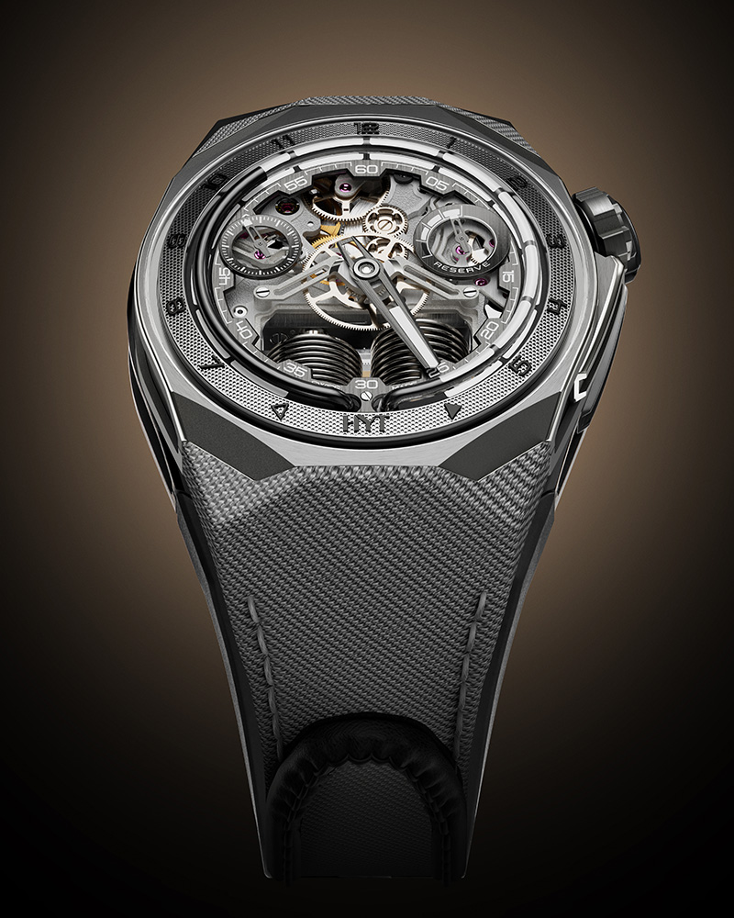 | Model  S1 Titanium  Japan Limited Edition  Reference: H03300-A  LIMITED EDITION: 8 PIECES  Suggested price: CHF 58’000 (excl. taxes)  Caseback ENGRAVING: S1 43  Non-contractual image
Case  - Silver and black coated satin finished titanium  - Titanium crown  - Sapphire crystal with anti-reflective coating  Dial  - Anthracite DLC & Rhodium plated brass  - Black DLC plated appliques, white decals,  SLN White C1 / WL  - Black liquid inside borosilicate capillary tube  - Water-resistant 50 m  Movement  - Ref.: 501-CM (352 pieces)  - Type: Mechanical  - Frequency: 28,800 vib/h (4 Hz)  - Jewels: 41  - Winding: Manual  - Power reserve: 72 h  - Finishing: Finely sand-blasted and satin-finished  - Coating: Silver coating |  | Functions  - Fluidic retrograde hours  - Central minutes hand  - Power reserve hand  hands  - Black gold satin-finished minutes hand, white SLN  - Black gold satin-finished seconds hand, white SLN  - Black gold satin-finished power reserve hand,  white SLN  straps  - Black rubber strap  - Galaxy Tec Silver Velcro strap  clasp  - Buckle in titanium  - Satin & sand-blasted finishes  Dimensions  - Width: 45,30 mm  - Length: 46,30 mm  - Thickness: 17,20 mm

